Vision of the Institute

***“To be a leader in imparting value based Technical Education and Research or the benefit of society”.***

Mission of the Institute

|  |  |
| --- | --- |
| **M1** | To Provide State-of-the-art Infrastructure Facilities |
| **M2** | To Implement modern Pedagogical Methods in delivering the Academic Programs with Experienced and Committed Faculty |
| **M3** | To Create a Vibrant Ambience that promotes Learning, Research, Invention and Innovation |
| **M4** | To Undertake Skill Development Programmes for Academic Institutions and Industries |
| **M5** | To Enhance Industry Institute Interaction through Collaborative Research and Consultancy |
| **M6** | To Relentlessly Pursue Professional Excellence with Ethical and Moral Values |

**DEPARTMENT OF COMPUTER SCIENCE AND ENGINEERING**

***Vision***

***“Be a premier department in the field of Computer Science & Engineering to meet the technological challenges of the society”***

***Mission of the Department***

|  |  |
| --- | --- |
| **MD 1** | To provide state of the art infrastructure facilities |
| **MD 2** | To provide exposure to the latest tools in the area of computer hardware and software |
| **MD 3** | To strive for academic excellence through research in Computer Science and Engineering with creative teaching-learning pedagogy |
| **MD 4** | To establish Industry Institute Interaction and make students ready for the Industrial environment |
| **MD 5** | To transform students into entrepreneurial, technically competent, socially responsible and ethical computer science professional |

# PROGRAMME EDUCATIONAL OBJECTIVES

|  |  |
| --- | --- |
| PEO 1 | Graduates possess advanced knowledge of Computer Science & Engineering and excel in leadership roles to serve the society |
| PEO 2 | Graduates of the program will apply Computer Engineering tools in  core technologies for improving knowledge in the Interdisciplinary Research and/or Entrepreneurs |
| PEO 3 | Graduates adapt Value-Based Proficiency in solving real time problems. |

**PROGRAMME SPECIFIC OUTCOMES**

|  |  |
| --- | --- |
| PSO 1 | Professional Skills: Ability of using mathematical methodologies for analysis of computing concepts, data structure, computer hardware, layered technologies and suitable algorithm which in turn helps graduates to model, design and implement a system to meet specific requirement |
| PSO 2 | Software Skills: Ability to build Software Engineering System for lifecycle development by using analytical knowledge in Computer Science & Engineering and applying modern methodologies |

# PROGRAM OUTCOMES (POS)

|  |  |
| --- | --- |
| **PO1** | **Engineering knowledge**: Apply the knowledge of mathematics, science, engineering fundamentals, and an engineering specialization to the solution of complex engineering  problems. |
| **PO2** | **Problem analysis**: Identify, formulate, review research literature, and analyze complex  engineering problems reaching substantiated conclusions using first principles of mathematics, natural sciences, and engineering sciences. |
| **PO3** | **Design/development of solutions**: Design solutions for complex engineering problems and design system components or processes that meet the specified needs with appropriate consideration for the public health and safety, and the cultural, societal, and environmental considerations. |
| **PO4** | **Conduct investigations of complex problems**: Use research-based knowledge and  research methods including design of experiments, analysis and interpretation of data, and synthesis of the information to provide valid conclusions |
| **PO5** | **Modern tool usage**: Create, select, and apply appropriate techniques, resources, and  modern engineering and IT tools including prediction and modeling to complex engineering activities with an understanding of the limitations. |
| **PO6** | **The engineer and society**: Apply reasoning informed by the contextual knowledge to  assess societal, health, safety, legal and cultural issues and the consequent responsibilities relevant to the professional engineering practice. |
| **PO7** | **Environment and sustainability**: Understand the impact of the professional  engineering solutions in societal and environmental contexts, and demonstrate the knowledge of, and need for sustainable development. |
| **PO8** | **Ethics**: Apply ethical principles and commit to professional ethics and responsibilities  and norms of the engineering practice. |
| **PO9** | **Individual and team work**: Function effectively as an individual, and as a member or  leader in diverse teams, and in multidisciplinary settings. |
| **PO10** | **Communication**: Communicate effectively on complex engineering activities with the engineering community and with society at large, such as, being able to comprehend and write effective reports and design documentation, make effective presentations, and  give and receive clear instructions. |
| **PO11** | **Project management and finance**: Demonstrate knowledge and understanding of the engineering and management principles and apply these to one’s own work, as a member and leader in a team, to manage projects and in multidisciplinary  environments. |
| **PO12** | **Life-long learning**: Recognize the need for, and have the preparation and ability to  engage in independent and life-long learning in the broadest context of technological change. |

**COURSE DETAILS**

**Course Name: DBMS Lab with Mini Project Subject Code: 18CSL58**

# COURSE OBJECTIVES

This course will enable students to

|  |  |
| --- | --- |
| 1 | Foundation knowledge in database concepts, technology and practice to groom students into well-informed database application developers. |
| 2 | Strong practice in SQL programming through a variety of database problems. |
| 3 | Develop database applications using front-end tools and back-end DBMS |

# SYLLABUS

### DBMS LABORATORY WITH MINI PROJECT

**[As per Choice Based Credit System (CBCS) scheme] (Effective from the academic year 2016 -2017)**

### Subject Code : 18CSL58 I.A. Marks : 40

**Hours/Week : 03 Exam Hours : 03**

### Total Hours : 40 Exam Marks : 60

**Description (If any):**

### PART-A: SQL Programming (Max. Exam Mks. 50)

* Design, develop, and implement the specified queries for the following problems using Oracle, MySQL, MS SQL Server, or any other DBMS under LINUX/Windows environment.
* Create Schema and insert at least 5 records for each table. Add appropriate database constraints.

### PART-B: Mini Project (Max. Exam Mks. 30)

* Use Java, C#, PHP, Python, or any other similar front-end tool. All applications must be demonstrated on desktop/laptop as a stand-alone or web based application (Mobile apps on Android/IOS are not permitted.)

**Lab Experiments:**

**Part A: SQL Programming**

1. Consider the following schema for a Library Database:

BOOK(Book_id, Title, Publisher_Name, Pub_Year) BOOK_AUTHORS(Book_id, Author_Name) PUBLISHER(Name, Address, Phone) BOOK_COPIES(Book_id, Branch_id, No-of_Copies)

BOOK_LENDING(Book_id, Branch_id, Card_No, Date_Out, Due_Date) LIBRARY_BRANCH(Branch_id, Branch_Name, Address)

Write SQL queries to

1. Retrieve details of all books in the library – id, title, name of publisher, authors, number of copies in each branch, etc.
2. Get the particulars of borrowers who have borrowed more than 3 books, but from Jan 2017 to Jun 2017.
3. Delete a book in BOOK table. Update the contents of other tables to reflect this data manipulation operation.
4. Partition the BOOK table based on year of publication. Demonstrate its working with a simple query.
5. Create a view of all books and its number of copies that are currently available in the Library.
6. Consider the following schema for Order Database: SALESMAN(Salesman_id, Name, City, Commission) CUSTOMER(Customer_id, Cust_Name, City, Grade, Salesman_id) ORDERS(Ord_No, Purchase_Amt, Ord_Date, Customer_id, Salesman_id) Write SQL queries to
   1. Count the customers with grades above Bangalore’s average.
   2. Find the name and numbers of all salesman who had more than one customer.
   3. List all the salesman and indicate those who have and don’t have customers in their cities (Use UNION operation.)
   4. Create a view that finds the salesman who has the customer with the highest order of a day.
   5. Demonstrate the DELETE operation by removing salesman with id 1000. All his orders must also be deleted.
7. Consider the schema for Movie Database:

ACTOR(Act_id, Act_Name, Act_Gender) DIRECTOR(Dir_id, Dir_Name, Dir_Phone) MOVIES(Mov_id, Mov_Title, Mov_Year, Mov_Lang, Dir_id) MOVIE_CAST(Act_id, Mov_id, Role)

RATING(Mov_id, Rev_Stars) Write SQL queries to

1. List the titles of all movies directed by ‘Hitchcock’.
2. Find the movie names where one or more actors acted in two or more movies.
3. List all actors who acted in a movie before 2000 and also in a movie after 2015 (use JOIN operation).
4. Find the title of movies and number of stars for each movie that has at least one rating and find the highest number of stars that movie received. Sort the result by movie title.
5. Update rating of all movies directed by ‘Steven Spielberg’ to 5.
6. Consider the schema for College Database:

STUDENT(USN, SName, Address, Phone, Gender) SEMSEC(SSID, Sem, Sec)

CLASS(USN, SSID)

SUBJECT(Subcode, Title, Sem, Credits)

IAMARKS(USN, Subcode, SSID, Test1, Test2, Test3, FinalIA) Write SQL queries to

1. List all the student details studying in fourth semester ‘C’ section.
2. Compute the total number of male and female students in each semester and in each section.
3. Create a view of Test1 marks of student USN ‘1BI15CS101’ in all subjects.
4. Calculate the FinalIA (average of best two test marks) and update the corresponding table for all students.
5. Categorize students based on the following criterion: If FinalIA = 17 to 20 then CAT = ‘Outstanding’

If FinalIA = 12 to 16 then CAT = ‘Average’ If FinalIA< 12 then CAT = ‘Weak’

Give these details only for 8th semester A, B, and C section students.

1. Consider the schema for Company Database:

EMPLOYEE(SSN, Name, Address, Sex, Salary, SuperSSN, DNo) DEPARTMENT(DNo, DName, MgrSSN, MgrStartDate) DLOCATION(DNo,DLoc)

PROJECT(PNo, PName, PLocation, DNo) WORKS_ON(SSN, PNo, Hours)

Write SQL queries to

1. Make a list of all project numbers for projects that involve an employee whose last name is ‘Scott’, either as a worker or as a manager of the department that controls the project.
2. Show the resulting salaries if every employee working on the ‘IoT’ project is given a 10 percent raise.
3. Find the sum of the salaries of all employees of the ‘Accounts’ department, as well as the maximum salary, the minimum salary, and the average salary in this department
4. Retrieve the name of each employee who works on all the projects Controlled by department number 5 (use NOT EXISTS operator).
5. For each department that has more than five employees, retrieve the department number and the number of its employees who are making more than Rs. 6,00,000.

### Part B: Mini project

* For any problem selected, write the ER Diagram, apply ER-mapping rules, normalize the relations, and follow the application development process.
* Make sure that the application should have five or more tables, at least one trigger and one stored procedure, using suitable frontend tool.
* Indicative areas include; health care, education, industry, transport, supply chain, etc.

**COURSE OUTCOMES**

At the end of the Course, the students will be able to:

|  |  |
| --- | --- |
| C358.1 | Design a database schema for a given problem-domain |
| C358.2 | Create ,populate , query and maintain tables of a database using PL/SQL |
| C358.3 | Demonstrate the working of different concepts of DBMS |
| C358.4 | Develop database applications using front-end tools and back-end DBMS. |
| C358.5 | Work with other people in a team, communicating ideas effectively in speech and in writing |

### CO-PO Mapping

|  |  |  |  |  |  |  |  |  |  |  |  |  |  |  |
| --- | --- | --- | --- | --- | --- | --- | --- | --- | --- | --- | --- | --- | --- | --- |
| **Cos** | **PO1** | **PO2** | **PO3** | **PO4** | **PO5** | **PO6** | **PO7** | **PO8** | **PO9** | **PO10** | **PO11** | **PO12** | **PSO1** | **PSO2** |
| C5.3.1 |  | 3 | 3 |  |  |  |  |  |  |  |  |  | 2 |  |
| C5.3.2 | 1 |  |  |  | 2 |  |  |  |  |  |  |  | 1 |  |
| C5.3.3 | 3 | 2 |  |  | 2 |  |  |  |  |  |  |  | 1 |  |
| C5.3.4 |  |  | 3 |  | 3 |  |  |  |  |  |  |  | 2 | 3 |
| C5.3.5 |  |  |  |  |  |  |  |  | 3 | 3 | 1 |  |  | 1 |
| **Avg.** | **2** | **2.5** | **3** |  | **2.3** |  |  |  | **3** | **3** | **1** |  | **1.5** | **2** |

**Conduction of Practical Examination:**

1. All laboratory experiments from part A are to be included for practical examination.
2. Mini project has to be evaluated for 30 Marks as per 6(b).
3. Report should be prepared in a standard format prescribed for project work.
4. Students are allowed to pick one experiment from the lot.
5. Strictly follow the instructions as printed on the cover page of answer script.
6. Marks distribution:
7. Part A: Procedure + Conduction + Viva:10 + 35 +5 =50 Marks
8. Part B: Demonstration + Report + Viva voce = 15+10+05 = 30 Marks
9. Change of experiment is allowed only once and marks allotted to the procedure part to be made zero.

# INTRODUCTION TO SQL

Pronounced as SEQUEL: Structured English QUERY Language

* + Pure non-procedural query language
  + Designed and developed by IBM, Implemented by Oracle
  + 1978 System/R IBM- 1st Relational DBMS
  + 1979 Oracle and Ingres
  + 1982 SQL/DS and DB2 IBM
  + Accepted by both ANSI + ISO as **Standard Query Language** for any RDBMS
  + SQL86 (SQL1) : first by ANSI and ratified by ISO (SQL-87), minor revision on 89 (SQL-89)
  + SQL92 (SQL2) : major revision
  + SQL99 (SQL3) : add recursive query, trigger, some OO features, and non-scholar type
  + SQL2003 : XML, Window functions, and sequences (Not free)
  + Supports all the three sublanguages of DBMS: **DDL, DML, DCL**
  + Supports Aggregate functions, String Manipulation functions, Set theory operations, Date Manipulation functions, rich set of operators ( IN, BETWEEN, LIKE, IS NULL, EXISTS)
  + Supports REPORT writing features and Forms for designing GUI based applications

**DATA DEFINITION, CONSTRAINTS, AND SCHEMA CHANGES**

Used to CREATE, ALTER, and DROP the descriptions of the database tables (relations)

### Data Definition in SQL CREATE, ALTER and DROP

table relation

row tuple

column… attribute

**DATA TYPES**

* + Numeric: NUMBER, NUMBER(s,p), INTEGER, INT, FLOAT, DECIMAL
  + Character: CHAR(n), VARCHAR(n), VARCHAR2(n), CHAR VARYING(n)
  + Bit String: BLOB, CLOB
  + Boolean: true, false, and null
  + Date and Time: DATE (YYYY-MM-DD) TIME( HH:MM:SS)
  + Timestamp: DATE + TIME
  + USER Defined types

**CREATE SCHEMA**

Specifies a new database schema by giving it a name

Ex: CREATE SCHEMA COMPANY AUTHORIZATION Jsmith;

**CREATE TABLE**

* + Specifies a new base relation by giving it a name, and specifying each of its attributes and their data types

Syntax of CREATE Command:

**CREATE TABLE <***table name>* ( <Attribute *A*1> <Data Type *D*1> [< Constarints>],

<Attribute *A*2> <Data Type *D*2> [< Constarints>],

*…….*

<Attribute *A*n> <Data Type *D*n> [< Constarints>], [<integrity-constraint1>, <integrity-constraint k> ] );

- A constraint NOT NULL may be specified on an attribute A constraint NOT NULL may be specified on an attribute

Ex: CREATE TABLE DEPARTMENT (DNAME VARCHAR(10) NOT NULL, DNUMBER INTEGER NOT NULL, MGRSSN CHAR(9), MGRSTARTDATE CHAR(9) );

* + Specifying the unique, primary key attributes, secondary keys, and referential integrity constraints (foreign keys).

Ex: CREATE TABLE DEPT ( DNAME VARCHAR(10) NOT NULL, DNUMBER INTEGER NOT NULL, MGRSSN CHAR(9), MGRSTARTDATE CHAR(9), PRIMARY KEY (DNUMBER), UNIQUE (DNAME),

FOREIGN KEY (MGRSSN) REFERENCES EMP(SSN));

* + We can specify RESTRICT, CASCADE, SET NULL or SET DEFAULT on referential integrity constraints (foreign keys)

Ex: CREATE TABLE DEPT ( DNAME VARCHAR(10) NOT NULL, DNUMBER INTEGER NOT NULL,

MGRSSN CHAR(9), MGRSTARTDATE CHAR(9), PRIMARY KEY (DNUMBER),

UNIQUE (DNAME),

FOREIGN KEY (MGRSSN) REFERENCES EMP

ON DELETE SET DEFAULT ON UPDATE CASCADE);

**DROP TABLE**

* + Used to remove a relation (base table) and its definition.
  + The relation can no longer be used in queries, updates, or any other commands since its description no longer exists

**Example:** DROP TABLE DEPENDENT;

**ALTER TABLE:**

* + Used to add an attribute to/from one of the base relations drop constraint -- The new attribute will have NULLs in all the tuples of the relation right after the command is executed; hence, the NOT NULL constraint is *not allowed* for such an attribute. **Example:** ALTER TABLE EMPLOYEE ADD JOB VARCHAR2 (12);
  + The database users must still enter a value for the new attribute JOB for each EMPLOYEE tuple. This can be done using the UPDATE command.

**DROP A COLUMN (AN ATTRIBUTE)**

* + ALTER TABLE COMPANY.EMPLOYEE DROP ADDRESS CASCADE; All constraints and views that reference the column are dropped automatically, along with the

column. ALTER TABLE COMPANY.EMPLOYEE DROP ADDRESS RESTRICT;

Successful if no views or constraints reference the column. ALTER TABLE COMPANY.DEPARTMENT ALTER MGRSSN DROP DEFAULT;

* + ALTER TABLE COMPANY.DEPARTMENT ALTER MGRSSN SET DEFAULT “333445555”;

**BASIC QUERIES IN SQL**

* + SQL has one basic statement for retrieving information from a database; the SLELECT statement
  + This is *not the same as* the SELECT operation of the relational algebra
  + Important distinction between SQL and the formal relational model;
  + SQL allows a table (relation) to have two or more tuples that are identical in all their attribute values
  + Hence, an SQL relation (table) is a *multi-set* (sometimes called a bag) of tuples; it is *not* a set of tuples
  + SQL relations can be constrained to be sets by using the CREATE UNIQUE INDEX command, or by using the DISTINCT option
  + Basic form of the SQL SELECT statement is called a *mapping* of a *SELECT-FROM- WHERE block*

SELECT <attribute list> FROM <table list> WHERE <condition>

* + <attribute list> is a list of attribute names whose values are to be retrieved by the query
  + <table list > is a list of the relation names required to process the query
  + <condition> is a conditional (Boolean) expression that identifies the tuples to be retrieved by the query

# LAB EXPERIMENTS

***PART A: SQL PROGRAMMING***

1. **Consider the following schema for a Library Database:**

**BOOK (*Book_id, Title, Publisher_Name, Pub_Year*) BOOK_AUTHORS (Book_id, Author_*Name*) PUBLISHER (*Name, Address, Phone*) BOOK_COPIES (*Book_id, Branch_id, No-of_Copies*)**

**BOOK_LENDING (*Book_id, Branch_id, Card_No, Date_Out, Due_Date*) LIBRARY_BRANCH (*Branch_id, Branch_Name, Address*)**

### Write SQL queries to

1. **Retrieve details of all books in the library – id, title, name of publisher, authors, number of copies in each branch, etc.**

### Get the particulars of borrowers who have borrowed more than 3 books, but from Jan 2017 to Jun 2017

1. **Delete a book in BOOK table. Update the contents of other tables to reflect this data manipulation operation.**

### Partition the BOOK table based on year of publication. Demonstrate its working with a simple query.

1. **Create a view of all books and its number of copies that are currently available in the Library.**

**Solution: Schema Diagram**

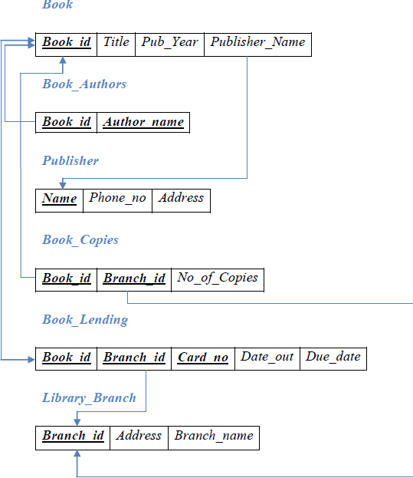

**Table Creation**

CREATE TABLE PUBLISHER

(NAME VARCHAR2 (20) PRIMARY KEY, PHONE INTEGER,

ADDRESS VARCHAR2 (20));

CREATE TABLE BOOK

(BOOK_ID INTEGER PRIMARY KEY, TITLE VARCHAR2 (20),

PUB_YEAR VARCHAR2 (20),

PUBLISHER_NAME REFERENCES PUBLISHER (NAME) ON DELETE CASCADE);

CREATE TABLE BOOK_AUTHORS (AUTHOR_NAME VARCHAR2 (20),

BOOK_ID REFERENCES BOOK (BOOK_ID) ON DELETE CASCADE, PRIMARY KEY (BOOK_ID, AUTHOR_NAME));

CREATE TABLE LIBRARY_BRANCH (BRANCH_ID INTEGER PRIMARY KEY, BRANCH_NAME VARCHAR2 (50),

ADDRESS VARCHAR2 (50));

CREATE TABLE BOOK_COPIES (NO_OF_COPIES INTEGER,

BOOK_ID REFERENCES BOOK (BOOK_ID) ON DELETE CASCADE,

BRANCH_ID REFERENCES LIBRARY_BRANCH (BRANCH_ID) ON DELETE CASCADE,

PRIMARY KEY (BOOK_ID, BRANCH_ID));

CREATE TABLE CARD

(CARD_NO INTEGER PRIMARY KEY);

CREATE TABLE BOOK_LENDING (DATE_OUT DATE,

DUE_DATE DATE,

BOOK_ID REFERENCES BOOK (BOOK_ID) ON DELETE CASCADE,

BRANCH_ID REFERENCES LIBRARY_BRANCH (BRANCH_ID) ON DELETE CASCADE,

CARD_NO REFERENCES CARD (CARD_NO) ON DELETE CASCADE, PRIMARY KEY (BOOK_ID, BRANCH_ID, CARD_NO));

**Table Descriptions**

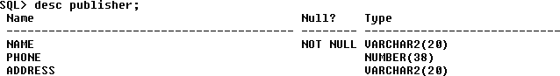DESC PUBLISHER;

DESC BOOK;

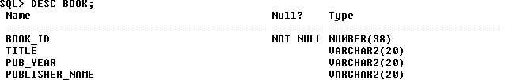

DESC BOOK_AUTHORS;

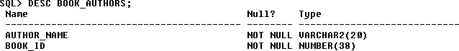

DESC LIBRARY_BRANCH;

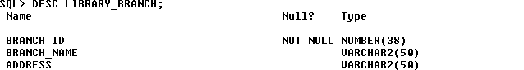

DESC BOOK_COPIES;

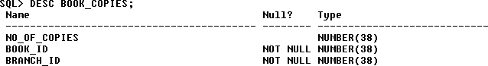

DESC CARD;



DESC BOOK_LENDING;

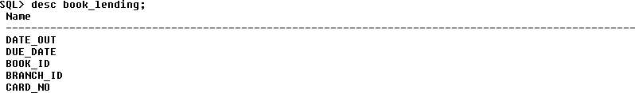

**Insertion of Values to Tables**

INSERT INTO PUBLISHER VALUES (‘MCGRAW-HILL’, 9989076587, ‘BANGALORE’);

INSERT INTO PUBLISHER VALUES (‘PEARSON’, 9889076565, ‘NEWDELHI’);

INSERT INTO PUBLISHER VALUES (‘RANDOM HOUSE’, 7455679345, ‘HYDRABAD’); INSERT INTO PUBLISHER VALUES (‘HACHETTE LIVRE’, 8970862340, ‘CHENAI’); INSERT INTO PUBLISHER VALUES (‘GRUPO PLANETA’, 7756120238, ‘BANGALORE’);

INSERT INTO BOOK VALUES (1,’DBMS’,’JAN-2017’, ‘MCGRAW-HILL’); INSERT INTO BOOK VALUES (2,’ADBMS’,’JUN-2016’, ‘MCGRAW-HILL’); INSERT INTO BOOK VALUES (3,’CN’,’SEP-2016’, ‘PEARSON’);

INSERT INTO BOOK VALUES (4,’CG’,’SEP-2015’, ‘GRUPO PLANETA’); INSERT INTO BOOK VALUES (5,’OS’,’MAY-2016’, ‘PEARSON’);

INSERT INTO BOOK_AUTHORS VALUES (’NAVATHE’, 1); INSERT INTO BOOK_AUTHORS VALUES (’NAVATHE’, 2); INSERT INTO BOOK_AUTHORS VALUES (’TANENBAUM’, 3); INSERT INTO BOOK_AUTHORS VALUES (’EDWARD ANGEL’, 4); INSERT INTO BOOK_AUTHORS VALUES (’GALVIN’, 5);

INSERT INTO LIBRARY_BRANCH VALUES (10,’RR NAGAR’,’BANGALORE’); INSERT INTO LIBRARY_BRANCH VALUES (11,’AMCEC’,’BANGALORE’); INSERT INTO LIBRARY_BRANCH VALUES (12,’RAJAJI NAGAR’, ’BANGALORE’); INSERT INTO LIBRARY_BRANCH VALUES (13,’NITTE’,’MANGALORE’);

INSERT INTO LIBRARY_BRANCH VALUES (14,’MANIPAL’,’UDUPI’);

INSERT INTO BOOK_COPIES VALUES (10, 1, 10);

INSERT INTO BOOK_COPIES VALUES (5, 1, 11);

INSERT INTO BOOK_COPIES VALUES (2, 2, 12);

INSERT INTO BOOK_COPIES VALUES (5, 2, 13);

INSERT INTO BOOK_COPIES VALUES (7, 3, 14);

INSERT INTO BOOK_COPIES VALUES (1, 5, 10);

INSERT INTO BOOK_COPIES VALUES (3, 4, 11);

INSERT INTO CARD VALUES (100); INSERT INTO CARD VALUES (101); INSERT INTO CARD VALUES (102); INSERT INTO CARD VALUES (103); INSERT INTO CARD VALUES (104);

INSERT INTO BOOK_LENDING VALUES (’01-JAN-17’,’01-JUN-17’, 1, 10, 101);

INSERT INTO BOOK_LENDING VALUES (’11-JAN-17’,’11-MAR-17’, 3, 14, 101);

INSERT INTO BOOK_LENDING VALUES (’21-FEB-17’,’21-APR-17’, 2, 13, 101);

INSERT INTO BOOK_LENDING VALUES (’15-MAR-17’,’15-JUL-17’, 4, 11, 101);

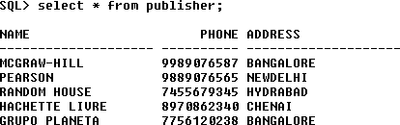INSERT INTO BOOK_LENDING VALUES (‘12-APR-17’,’12-MAY-17’, 1, 11, 104); SELECT * FROM PUBLISHER;

SELECT * FROM BOOK;

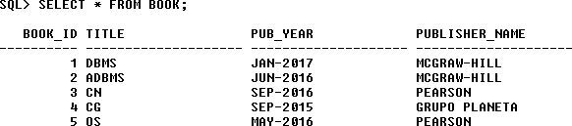

SELECT * FROM BOOK_AUTHORS;

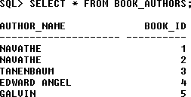

SELECT * FROM LIBRARY_BRANCH;

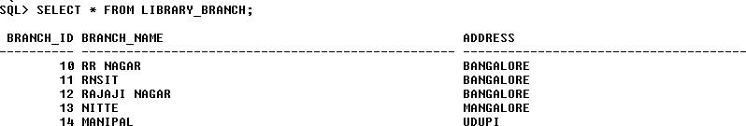

SELECT * FROM BOOK_COPIES;

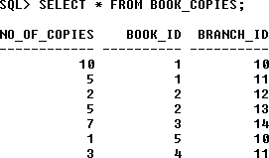

SELECT * FROM CARD;

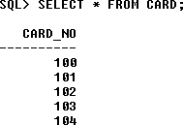

SELECT * FROM BOOK_LENDING;

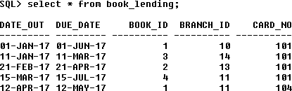

**Queries:**

* 1. **Retrieve details of all books in the library – id, title, name of publisher, authors, number of copies in each branch, etc.**

SELECT B.BOOK_ID, B.TITLE, B.PUBLISHER_NAME, A.AUTHOR_NAME, C.NO_OF_COPIES, L.BRANCH_ID

FROM BOOK B, BOOK_AUTHORS A, BOOK_COPIES C, LIBRARY_BRANCH L WHERE B.BOOK_ID=A.BOOK_ID

AND B.BOOK_ID=C.BOOK_ID

AND L.BRANCH_ID=C.BRANCH_ID;

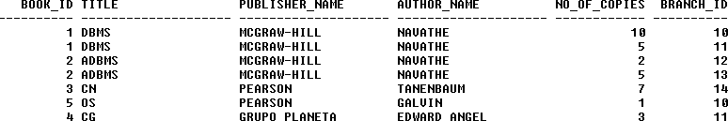

### Get the particulars of borrowers who have borrowed more than 3 books, but from Jan 2017 to Jun 2017.

SELECT CARD_NO FROM BOOK_LENDING

WHERE DATE_OUT BETWEEN ’01-JAN-2017’ AND ’01-JUL-2017’ GROUP BY CARD_NO

HAVING COUNT (*)>3;



### Delete a book in BOOK table. Update the contents of other tables to reflect this data manipulation operation.

DELETE FROM BOOK WHERE BOOK_ID=3;

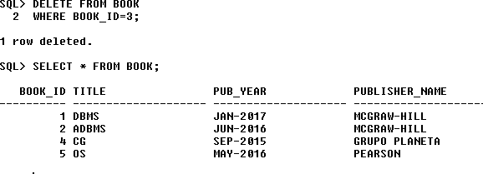

### Partition the BOOK table based on year of publication. Demonstrate its working with a simple query.

CREATE VIEW V_PUBLICATION AS SELECT PUB_YEAR

FROM BOOK;

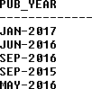

### Create a view of all books and its number of copies that are currently available in the Library.

CREATE VIEW V_BOOKS AS

SELECT B.BOOK_ID, B.TITLE, C.NO_OF_COPIES

FROM BOOK B, BOOK_COPIES C, LIBRARY_BRANCH L WHERE B.BOOK_ID=C.BOOK_ID

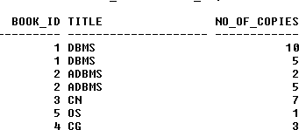AND C.BRANCH_ID=L.BRANCH_ID;

### Consider the following schema for Order Database:

**SALESMAN (*Salesman_id, Name, City, Commission*) CUSTOMER (*Customer_id, Cust_Name, City, Grade, Salesman_id*)**

**ORDERS (*Ord_No, Purchase_Amt, Ord_Date, Customer_id, Salesman_id*) Write SQL queries to**

### Count the customers with grades above Bangalore’s average.

1. **Find the name and numbers of all salesmen who had more than one customer.**

### List all salesmen and indicate those who have and don’t have customers in their cities (Use UNION operation.)

1. **Create a view that finds the salesman who has the customer with the highest order of a day.**

### Demonstrate the DELETE operation by removing salesman with id 1000. All his orders must also be deleted.

**Solution: Schema Diagram**

***Salesman***



***Orders***

|  |  |  |  |
| --- | --- | --- | --- |
| ***Salesman_id*** | *Name* | *City* | *Commission* |

|  |  |  |  |  |  |
| --- | --- | --- | --- | --- | --- |
| ***Customer*** | | | | |  |
| ***Customer_id*** | *Cust_Name* | *City* | *Grade* | *Salesman_id* | |

|  |  |  |  |  |  |
| --- | --- | --- | --- | --- | --- |
|  | ***Ord_No*** | *Purchase_Amt* | *Ord_Date* | *Customer_id* | *Salesman_id* |

**Table Creation**

CREATE TABLE SALESMAN (SALESMAN_ID NUMBER (4),

NAME VARCHAR2 (20),

CITY VARCHAR2 (20),

COMMISSION VARCHAR2 (20), PRIMARY KEY (SALESMAN_ID)); CREATE TABLE CUSTOMER1 (CUSTOMER_ID NUMBER (4),

CUST_NAME VARCHAR2 (20),

CITY VARCHAR2 (20),

GRADE NUMBER (3),

PRIMARY KEY (CUSTOMER_ID),

SALESMAN_ID REFERENCES SALESMAN (SALESMAN_ID) ON DELETE SET NULL);

CREATE TABLE ORDERS (ORD_NO NUMBER (5),

PURCHASE_AMT NUMBER (10, 2), ORD_DATE DATE,

PRIMARY KEY (ORD_NO),

CUSTOMER_ID REFERENCES CUSTOMER1 (CUSTOMER_ID) ON DELETE CASCADE, SALESMAN_ID REFERENCES SALESMAN (SALESMAN_ID) ON DELETE CASCADE);

**Table Descriptions**

DESC SALESMAN;

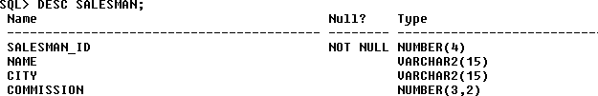

DESC CUSTOMER1;

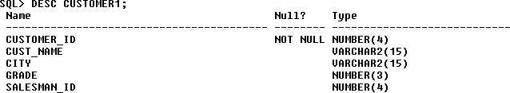

DESC ORDERS;

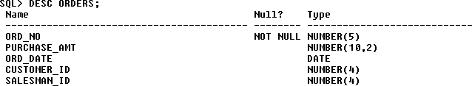

**Insertion of Values to Tables**

INSERT INTO SALESMAN VALUES (1000, ‘JOHN’,’BANGALORE’,’25 %’); INSERT INTO SALESMAN VALUES (2000, ‘RAVI’,’BANGALORE’,’20 %’); INSERT INTO SALESMAN VALUES (3000, ‘KUMAR’,’MYSORE’,’15 %’);

INSERT INTO SALESMAN VALUES (4000, ‘SMITH’,’DELHI’,’30 %’); INSERT INTO SALESMAN VALUES (5000, ‘HARSHA’,’HYDRABAD’,’15 %’);

INSERT INTO CUSTOMER1 VALUES (10, ‘PREETHI’,’BANGALORE’, 100, 1000);

INSERT INTO CUSTOMER1 VALUES (11, ‘VIVEK’,’MANGALORE’, 300, 1000);

INSERT INTO CUSTOMER1 VALUES (12, ‘BHASKAR’,’CHENNAI’, 400, 2000);

INSERT INTO CUSTOMER1 VALUES (13, ‘CHETHAN’,’BANGALORE’, 200, 2000);

INSERT INTO CUSTOMER1 VALUES (14, ‘MAMATHA’,’BANGALORE’, 400, 3000);

INSERT INTO ORDERS VALUES (50, 5000, ‘04-MAY-17’, 10, 1000);

INSERT INTO ORDERS VALUES (51, 450, ‘20-JAN-17’, 10, 2000);

INSERT INTO ORDERS VALUES (52, 1000, ‘24-FEB-17’, 13, 2000);

INSERT INTO ORDERS VALUES (53, 3500, ‘13-APR-17’, 14, 3000);

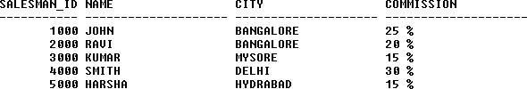INSERT INTO ORDERS VALUES (54, 550, ‘09-MAR-17’, 12, 2000); SELECT * FROM SALESMAN;

SELECT * FROM CUSTOMER1;

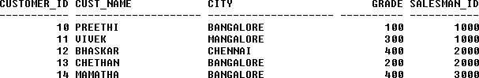

SELECT * FROM ORDERS;

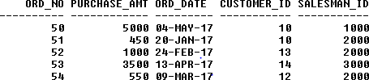

**Queries:**

* 1. **Count the customers with grades above Bangalore’s average.** SELECT GRADE, COUNT (DISTINCT CUSTOMER_ID) FROM CUSTOMER1

GROUP BY GRADE

HAVING GRADE > (SELECT AVG(GRADE) FROM CUSTOMER1

WHERE CITY='BANGALORE');



### Find the name and numbers of all salesmen who had more than one customer.

SELECT SALESMAN_ID, NAME FROM SALESMAN A

WHERE 1 < (SELECT COUNT (*) FROM CUSTOMER1

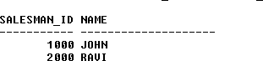WHERE SALESMAN_ID=A.SALESMAN_ID);

### List all salesmen and indicate those who have and don’t have customers in their cities (Use UNION operation.)

SELECT SALESMAN.SALESMAN_ID, NAME, CUST_NAME, COMMISSION FROM SALESMAN, CUSTOMER1

WHERE SALESMAN.CITY = CUSTOMER1.CITY UNION

SELECT SALESMAN_ID, NAME, 'NO MATCH', COMMISSION FROM SALESMAN

WHERE NOT CITY = ANY (SELECT CITY

FROM CUSTOMER1) ORDER BY 2 DESC;

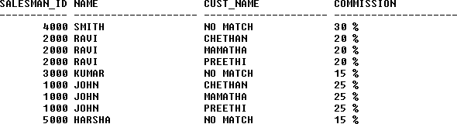

### Create a view that finds the salesman who has the customer with the highest order of a day.

CREATE VIEW ELITSALESMAN AS

SELECT B.ORD_DATE, A.SALESMAN_ID, A.NAME FROM SALESMAN A, ORDERS B

WHERE A.SALESMAN_ID = B.SALESMAN_ID

AND B.PURCHASE_AMT=(SELECT MAX (PURCHASE_AMT)

FROM ORDERS C

WHERE C.ORD_DATE = B.ORD_DATE);

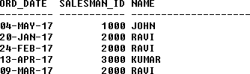

### Demonstrate the DELETE operation by removing salesman with id 1000. All his orders must also be deleted.

Use ON DELETE CASCADE at the end of foreign key definitions while creating child table orders and then execute the following:

Use ON DELETE SET NULL at the end of foreign key definitions while creating child table customers and then executes the following:

DELETE FROM SALESMAN WHERE SALESMAN_ID=1000;

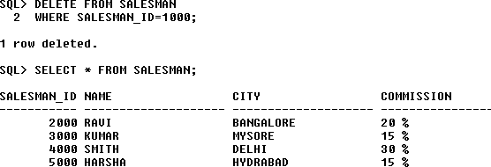

1. **Consider the schema for Movie Database: ACTOR (*Act_id, Act_Name, Act_Gender*) DIRECTOR (*Dir_id, Dir_Name, Dir_Phone*)**

**MOVIES (*Mov_id, Mov_Title, Mov_Year, Mov_Lang, Dir_id*) MOVIE_CAST (*Act_id, Mov_id, Role*)**

**RATING (*Mov_id, Rev_Stars*) Write SQL queries to**

### List the titles of all movies directed by ‘Hitchcock’.

* 1. **Find the movie names where one or more actors acted in two or more movies.**

### List all actors who acted in a movie before 2000 and also in a movie after 2015 (use JOIN operation).

* 1. **Find the title of movies and number of stars for each movie that has at least one rating and find the highest number of stars that movie received. Sort the result by movie title.**

### Update rating of all movies directed by ‘Steven Spielberg’ to 5. Solution:

**Schema Diagram**

***Actor***



***Director***

***Movie_Cast***

|  |  |  |
| --- | --- | --- |
| ***Act_id*** | *Act_Name* | *Act_Gender* |

|  |  |  |
| --- | --- | --- |
| ***Dir_id*** | *Dir_Name* | *Dir_Phone* |

|  |  |  |  |  |  |
| --- | --- | --- | --- | --- | --- |
| ***Movies*** | | | | |  |
| ***Mov_id*** | *Mov_Title* | *Mov_Year* | *Mov_Lang* | *Dir_id* | |

|  |  |  |  |
| --- | --- | --- | --- |
|  | ***Act_id*** | ***Mov_id*** | *Role* |

|  |  |
| --- | --- |
| ***Rating*** |  |
| ***Mov_id*** | *Rev_Stars* |

**Table Creation**

CREATE TABLE ACTOR ( ACT_ID NUMBER (3),

ACT_NAME VARCHAR (20),

ACT_GENDER CHAR (1), PRIMARY KEY (ACT_ID));

CREATE TABLE DIRECTOR ( DIR_ID NUMBER (3),

DIR_NAME VARCHAR (20),

DIR_PHONE NUMBER (10), PRIMARY KEY (DIR_ID));

CREATE TABLE MOVIES ( MOV_ID NUMBER (4),

MOV_TITLE VARCHAR (25),

MOV_YEAR NUMBER (4),

MOV_LANG VARCHAR (12),

DIR_ID NUMBER (3), PRIMARY KEY (MOV_ID),

FOREIGN KEY (DIR_ID) REFERENCES DIRECTOR (DIR_ID));

CREATE TABLE MOVIE_CAST ( ACT_ID NUMBER (3),

MOV_ID NUMBER (4),

ROLE VARCHAR (10),

PRIMARY KEY (ACT_ID, MOV_ID),

FOREIGN KEY (ACT_ID) REFERENCES ACTOR (ACT_ID), FOREIGN KEY (MOV_ID) REFERENCES MOVIES (MOV_ID));

CREATE TABLE RATING ( MOV_ID NUMBER (4),

REV_STARS VARCHAR (25), PRIMARY KEY (MOV_ID),

FOREIGN KEY (MOV_ID) REFERENCES MOVIES (MOV_ID));

**Table Descriptions**

DESC ACTOR;

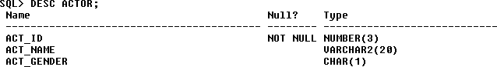

DESC DIRECTOR;

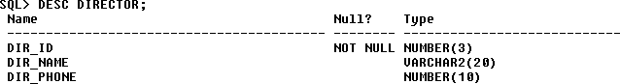

DESC MOVIES;

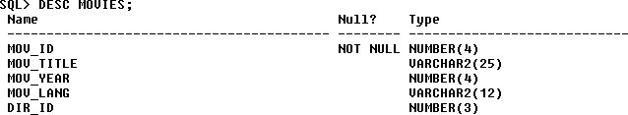

DESC MOVIE_CAST;

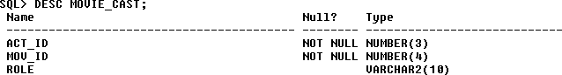

DESC RATING;

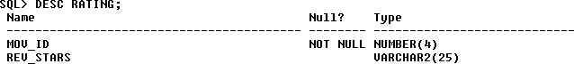

**Insertion of Values to Tables**

INSERT INTO ACTOR VALUES (301,’ANUSHKA’,’F’); INSERT INTO ACTOR VALUES (302,’PRABHAS’,’M’); INSERT INTO ACTOR VALUES (303,’PUNITH’,’M’); INSERT INTO ACTOR VALUES (304,’JERMY’,’M’);

INSERT INTO DIRECTOR VALUES (60,’RAJAMOULI’, 8751611001); INSERT INTO DIRECTOR VALUES (61,’HITCHCOCK’, 7766138911); INSERT INTO DIRECTOR VALUES (62,’FARAN’, 9986776531);

INSERT INTO DIRECTOR VALUES (63,’STEVEN SPIELBERG’, 8989776530);

INSERT INTO MOVIES VALUES (1001,’BAHUBALI-2’, 2017, ‘TELAGU’, 60); INSERT INTO MOVIES VALUES (1002,’BAHUBALI-1’, 2015, ‘TELAGU’, 60); INSERT INTO MOVIES VALUES (1003,’AKASH’, 2008, ‘KANNADA’, 61); INSERT INTO MOVIES VALUES (1004,’WAR HORSE’, 2011, ‘ENGLISH’, 63);

INSERT INTO MOVIE_CAST VALUES (301, 1002, ‘HEROINE’); INSERT INTO MOVIE_CAST VALUES (301, 1001, ‘HEROINE’); INSERT INTO MOVIE_CAST VALUES (303, 1003, ‘HERO’); INSERT INTO MOVIE_CAST VALUES (303, 1002, ‘GUEST’); INSERT INTO MOVIE_CAST VALUES (304, 1004, ‘HERO’);

INSERT INTO RATING VALUES (1001, 4);

INSERT INTO RATING VALUES (1002, 2);

INSERT INTO RATING VALUES (1003, 5);

INSERT INTO RATING VALUES (1004, 4); SELECT * FROM ACTOR;

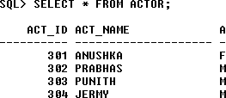

SELECT * FROM DIRECTOR;

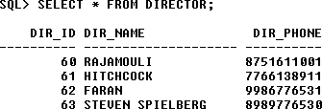

SELECT * FROM MOVIES;

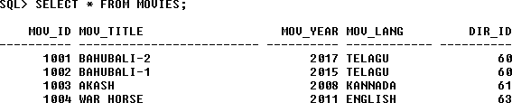

SELECT * FROM MOVIE_CAST;

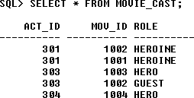

SELECT * FROM RATING;

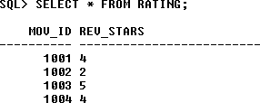

**Queries:**

1. **List the titles of all movies directed by ‘Hitchcock’.**

SELECT MOV_TITLE FROM MOVIES

WHERE DIR_ID IN (SELECT DIR_ID

FROM DIRECTOR

WHERE DIR_NAME = ‘HITCHCOCK’);



### Find the movie names where one or more actors acted in two or more movies.

SELECT MOV_TITLE

FROM MOVIES M, MOVIE_CAST MV

WHERE M.MOV_ID=MV.MOV_ID AND ACT_ID IN (SELECT ACT_ID

FROM MOVIE_CAST GROUP BY ACT_ID HAVING COUNT (ACT_ID)>1)

GROUP BY MOV_TITLE HAVING COUNT (*)>1;



### List all actors who acted in a movie before 2000 and also in a movie after 2015 (use JOIN operation).

SELECT ACT_NAME, MOV_TITLE, MOV_YEAR FROM ACTOR A

JOIN MOVIE_CAST C

ON A.ACT_ID=C.ACT_ID JOIN MOVIES M

ON C.MOV_ID=M.MOV_ID

WHERE M.MOV_YEAR NOT BETWEEN 2000 AND 2015;

### OR

SELECT A.ACT_NAME, A.ACT_NAME, C.MOV_TITLE, C.MOV_YEAR FROM ACTOR A, MOVIE_CAST B, MOVIES C

WHERE A.ACT_ID=B.ACT_ID AND B.MOV_ID=C.MOV_ID

AND C.MOV_YEAR NOT BETWEEN 2000 AND 2015;



### Find the title of movies and number of stars for each movie that has at least one rating and find the highest number of stars that movie received. Sort the result by movie title.

SELECT MOV_TITLE, MAX (REV_STARS) FROM MOVIES

INNER JOIN RATING USING (MOV_ID) GROUP BY MOV_TITLE

HAVING MAX (REV_STARS)>0 ORDER BY MOV_TITLE;

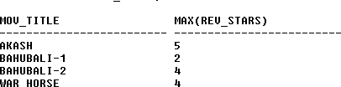

### Update rating of all movies directed by ‘Steven Spielberg’ to 5

UPDATE RATING SET REV_STARS=5

WHERE MOV_ID IN (SELECT MOV_ID FROM MOVIES

WHERE DIR_ID IN (SELECT DIR_ID

FROM DIRECTOR

WHERE DIR_NAME = ‘STEVEN SPIELBERG’));

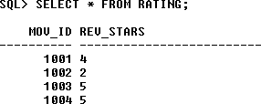

### Consider the schema for College Database:

**STUDENT (*USN, SName, Address, Phone, Gender*) SEMSEC (*SSID, Sem, Sec*)**

**CLASS (*USN, SSID*)**

**SUBJECT (*Subcode, Title, Sem, Credits*)**

**IAMARKS (*USN, Subcode, SSID, Test1, Test2, Test3, FinalIA*) Write SQL queries to**

### List all the student details studying in fourth semester ‘C’ section.

* 1. **Compute the total number of male and female students in each semester and in each section.**

### Create a view of Test1 marks of student USN ‘1BI15CS101’ in all subjects.

* 1. **Calculate the FinalIA (average of best two test marks) and update the corresponding table for all students.**

### Categorize students based on the following criterion: If FinalIA = 17 to 20 then CAT = ‘Outstanding’

**If FinalIA = 12 to 16 then CAT = ‘Average’ If FinalIA< 12 then CAT = ‘Weak’**

### Give these details only for 8th semester A, B, and C section students.

**Solution: Schema Diagram**

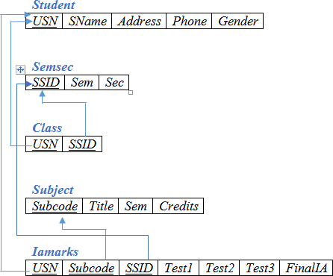

**Table Creation**

CREATE TABLE STUDENT (

USN VARCHAR (10) PRIMARY KEY, SNAME VARCHAR (25),

ADDRESS VARCHAR (25),

PHONE NUMBER (10),

GENDER CHAR (1));

CREATE TABLE SEMSEC (

SSID VARCHAR (5) PRIMARY KEY, SEM NUMBER (2),

SEC CHAR (1));

CREATE TABLE CLASS ( USN VARCHAR (10),

SSID VARCHAR (5), PRIMARY KEY (USN, SSID),

FOREIGN KEY (USN) REFERENCES STUDENT (USN), FOREIGN KEY (SSID) REFERENCES SEMSEC (SSID)); CREATE TABLE SUBJECT (

SUBCODE VARCHAR (8),

TITLE VARCHAR (20),

SEM NUMBER (2),

CREDITS NUMBER (2), PRIMARY KEY (SUBCODE));

CREATE TABLE IAMARKS ( USN VARCHAR (10),

SUBCODE VARCHAR (8),

SSID VARCHAR (5),

TEST1 NUMBER (2),

TEST2 NUMBER (2),

TEST3 NUMBER (2),

FINALIA NUMBER (2),

PRIMARY KEY (USN, SUBCODE, SSID),

FOREIGN KEY (USN) REFERENCES STUDENT (USN),

FOREIGN KEY (SUBCODE) REFERENCES SUBJECT (SUBCODE), FOREIGN KEY (SSID) REFERENCES SEMSEC (SSID));

**Table Descriptions**

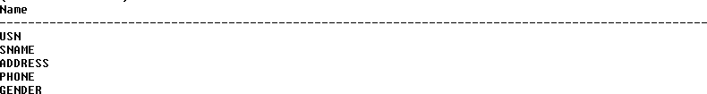DESC STUDENT;

DESC SEMSEC;

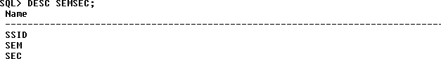

DESC CLASS;

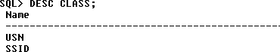

DESC SUBJECT;

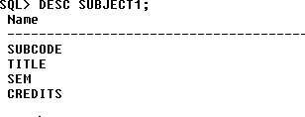

DESC IAMARKS;

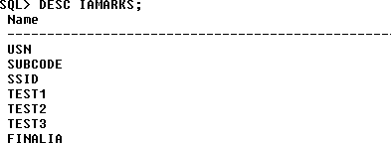

**Insertion of values to tables**

INSERT INTO STUDENT VALUES ('1RN13CS020','AKSHAY','BELAGAVI', 8877881122,'M');

INSERT INTO STUDENT VALUES ('1RN13CS062','SANDHYA','BENGALURU', 7722829912,'F');

INSERT INTO STUDENT VALUES ('1RN13CS091','TEESHA','BENGALURU', 7712312312,'F');

INSERT INTO STUDENT VALUES ('1RN13CS066','SUPRIYA','MANGALURU', 8877881122,'F');

INSERT INTO STUDENTVALUES ('1RN14CS010','ABHAY','BENGALURU', 9900211201,'M');

INSERT INTO STUDENT VALUES ('1RN14CS032','BHASKAR','BENGALURU', 9923211099,'M');

INSERT INTO STUDENTVALUES ('1RN14CS025','ASMI','BENGALURU', 7894737377,'F'); INSERT INTO STUDENT VALUES ('1RN15CS011','AJAY','TUMKUR', 9845091341,'M'); INSERT INTO STUDENT VALUES ('1RN15CS029','CHITRA','DAVANGERE', 7696772121,'F');

INSERT INTO STUDENT VALUES ('1RN15CS045','JEEVA','BELLARY', 9944850121,'M'); INSERT INTO STUDENT VALUES ('1RN15CS091','SANTOSH','MANGALURU', 8812332201,'M');

INSERT INTO STUDENT VALUES ('1RN16CS045','ISMAIL','KALBURGI', 9900232201,'M');

INSERT INTO STUDENT VALUES ('1RN16CS088','SAMEERA','SHIMOGA', 9905542212,'F');

INSERT INTO STUDENT VALUES ('1RN16CS122','VINAYAKA','CHIKAMAGALUR', 8800880011,'M');

INSERT INTO SEMSEC VALUES ('CSE8A', 8,'A'); INSERT INTO SEMSEC VALUES (‘CSE8B', 8,'B'); INSERT INTO SEMSEC VALUES (‘CSE8C’, 8,’C’);

INSERT INTO SEMSEC VALUES ('CSE7A', 7,’A’); INSERT INTO SEMSEC VALUES (‘CSE7B’, 7,'B’); INSERT INTO SEMSEC VALUES ('CSE7C', 7,'C');

INSERT INTO SEMSEC VALUES (‘CSE6A', 6,'A'); INSERT INTO SEMSEC VALUES (‘CSE6B’, 6,’B’); INSERT INTO SEMSEC VALUES ('CSE6C’, 6,’C’);

INSERT INTO SEMSEC VALUES (‘CSE5A’, 5,'A’); INSERT INTO SEMSEC VALUES ('CSE5B', 5,'B'); INSERT INTO SEMSEC VALUES (‘CSE5C', 5,'C');

INSERT INTO SEMSEC VALUES (‘CSE4A’, 4,’A’); INSERT INTO SEMSEC VALUES ('CSE4B', 4,’B’);

INSERT INTO SEMSEC VALUES (‘CSE4C’, 4,'C’);

INSERT INTO SEMSEC VALUES ('CSE3A', 3,'A'); INSERT INTO SEMSEC VALUES (‘CSE3B', 3,'B'); INSERT INTO SEMSEC VALUES (‘CSE3C’, 3,’C’);

INSERT INTO SEMSEC VALUES ('CSE2A', 2,’A’); INSERT INTO SEMSEC VALUES (‘CSE2B’, 2,'B’); INSERT INTO SEMSEC VALUES ('CSE2C', 2,'C'); INSERT INTO SEMSEC VALUES (‘CSE1A', 1,'A'); INSERT INTO SEMSEC VALUES (‘CSE1B’, 1,’B’); INSERT INTO SEMSEC VALUES ('CSE1C', 1,’C’);

INSERT INTO CLASS VALUES (‘1RN13CS020’,’CSE8A’); INSERT INTO CLASS VALUES (‘1RN13CS062’,’CSE8A’); INSERT INTO CLASS VALUES (‘1RN13CS066’,’CSE8B’); INSERT INTO CLASS VALUES (‘1RN13CS091’,’CSE8C’);

INSERT INTO CLASS VALUES (‘1RN14CS010’,’CSE7A’); INSERT INTO CLASS VALUES (‘1RN14CS025’,’CSE7A’); INSERT INTO CLASS VALUES (‘1RN14CS032’,’CSE7A’);

INSERT INTO CLASS VALUES (‘1RN15CS011’,’CSE4A’); INSERT INTO CLASS VALUES (‘1RN15CS029’,’CSE4A’); INSERT INTO CLASS VALUES (‘1RN15CS045’,’CSE4B’); INSERT INTO CLASS VALUES (‘1RN15CS091’,’CSE4C’);

INSERT INTO CLASS VALUES (‘1RN16CS045’,’CSE3A’); INSERT INTO CLASS VALUES (‘1RN16CS088’,’CSE3B’); INSERT INTO CLASS VALUES (‘1RN16CS122’,’CSE3C’);

INSERT INTO SUBJECT VALUES ('10CS81','ACA', 8, 4); INSERT INTO SUBJECT VALUES ('10CS82','SSM', 8, 4); INSERT INTO SUBJECT VALUES ('10CS83','NM', 8, 4); INSERT INTO SUBJECT VALUES ('10CS84','CC', 8, 4); INSERT INTO SUBJECT VALUES ('10CS85','PW', 8, 4);

INSERT INTO SUBJECT VALUES ('10CS71','OOAD', 7, 4); INSERT INTO SUBJECT VALUES ('10CS72','ECS', 7, 4); INSERT INTO SUBJECT VALUES ('10CS73','PTW', 7, 4);

INSERT INTO SUBJECT VALUES ('10CS74','DWDM', 7, 4); INSERT INTO SUBJECT VALUES (‘10CS75','JAVA', 7, 4); INSERT INTO SUBJECT VALUES ('10CS76','SAN', 7, 4);

INSERT INTO SUBJECT VALUES ('15CS51', 'ME', 5, 4); INSERT INTO SUBJECT VALUES ('15CS52','CN', 5, 4); INSERT INTO SUBJECT VALUES ('15CS53','DBMS', 5, 4); INSERT INTO SUBJECT VALUES ('15CS54','ATC', 5, 4); INSERT INTO SUBJECT VALUES ('15CS55','JAVA', 5, 3); INSERT INTO SUBJECT VALUES ('15CS56','AI', 5, 3); INSERT INTO SUBJECT VALUES ('15CS41','M4', 4, 4); INSERT INTO SUBJECT VALUES ('15CS42','SE', 4, 4); INSERT INTO SUBJECT VALUES ('15CS43','DAA', 4, 4); INSERT INTO SUBJECT VALUES ('15CS44','MPMC', 4, 4); INSERT INTO SUBJECT VALUES ('15CS45','OOC', 4, 3); INSERT INTO SUBJECT VALUES ('15CS46','DC', 4, 3);

INSERT INTO SUBJECT VALUES ('15CS31','M3', 3, 4); INSERT INTO SUBJECT VALUES ('15CS32','ADE', 3, 4); INSERT INTO SUBJECT VALUES ('15CS33','DSA', 3, 4); INSERT INTO SUBJECT VALUES ('15CS34','CO', 3, 4); INSERT INTO SUBJECT VALUES ('15CS35','USP', 3, 3); INSERT INTO SUBJECT VALUES ('15CS36','DMS', 3, 3);

INSERT INTO IAMARKS (USN, SUBCODE, SSID, TEST1, TEST2, TEST3) VALUES ('1RN13CS091','10CS81','CSE8C', 15, 16, 18);

INSERT INTO IAMARKS (USN, SUBCODE, SSID, TEST1, TEST2, TEST3) VALUES ('1RN13CS091','10CS82','CSE8C', 12, 19, 14);

INSERT INTO IAMARKS (USN, SUBCODE, SSID, TEST1, TEST2, TEST3) VALUES ('1RN13CS091','10CS83','CSE8C', 19, 15, 20);

INSERT INTO IAMARKS (USN, SUBCODE, SSID, TEST1, TEST2, TEST3) VALUES ('1RN13CS091','10CS84','CSE8C', 20, 16, 19);

INSERT INTO IAMARKS (USN, SUBCODE, SSID, TEST1, TEST2, TEST3) VALUES ('1RN13CS091','10CS85','CSE8C', 15, 15, 12);

SELECT * FROM STUDENT;

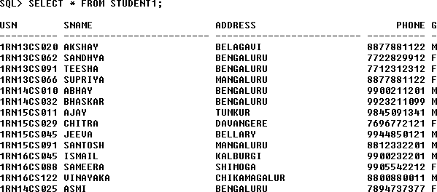

SELECT * FROM SEMSEC;

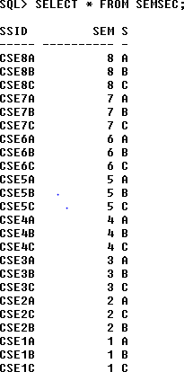

SELECT * FROM CLASS;

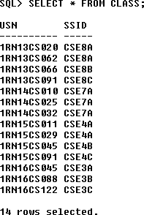

SELECT * FROM SUBJECT;

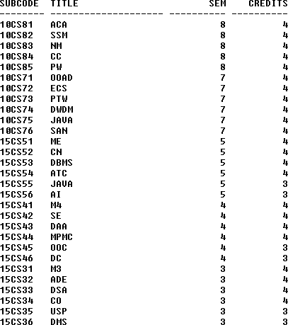

SELECT * FROM IAMARKS;

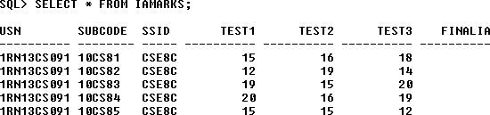

**Queries:**

1. **List all the student details studying in fourth semester ‘C’ section.**

SELECT S.*, SS.SEM, SS.SEC

FROM STUDENT S, SEMSEC SS, CLASS C WHERE S.USN = C.USN AND

SS.SSID = C.SSID AND SS.SEM = 4 AND SS.SEc=’C’;



### Compute the total number of male and female students in each semester and in each section.

SELECT SS.SEM, SS.SEC, S.GENDER, COUNT (S.GENDER) AS COUNT FROM STUDENT S, SEMSEC SS, CLASS C

WHERES.USN = C.USN AND SS.SSID = C.SSID

GROUP BY SS.SEM, SS.SEC, S.GENDER ORDER BY SEM;

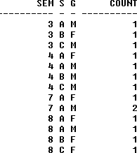

### Create a view of Test1 marks of student USN ‘1BI15CS101’ in all subjects.

CREATE VIEW STU_TEST1_MARKS_VIEW AS

SELECT TEST1, SUBCODE FROM IAMARKS

WHERE USN = '1RN13CS091';

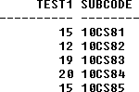

### Calculate the Final IA (average of best two test marks) and update the corresponding table for all students.

CREATE OR REPLACE PROCEDURE AVGMARKS IS

CURSOR C_IAMARKS IS

SELECT GREATEST(TEST1,TEST2) AS A, GREATEST(TEST1,TEST3) AS B, GREATEST(TEST3,TEST2) AS C

FROM IAMARKS

WHERE FINALIA IS NULL FOR UPDATE;

C_A NUMBER;

C_B NUMBER;

C_C NUMBER;

C_SM NUMBER;

C_AV NUMBER;

BEGIN

OPEN C_IAMARKS;

LOOP

FETCH C_IAMARKS INTO C_A, C_B, C_C; EXIT WHEN C_IAMARKS%NOTFOUND;

--DBMS_OUTPUT.PUT_LINE(C_A || ' ' || C_B || ' ' || C_C); IF (C_A != C_B) THEN

C_SM:=C_A+C_B; ELSE

C_SM:=C_A+C_C;

END IF;

C_AV:=C_SM/2;

--DBMS_OUTPUT.PUT_LINE('SUM = '||C_SM);

--DBMS_OUTPUT.PUT_LINE('AVERAGE = '||C_AV);

UPDATE IAMARKS SET FINALIA=C_AV WHERE CURRENT OF C_IAMARKS;

END LOOP;

CLOSE C_IAMARKS; END;

/

**Note:** Before execution of PL/SQL procedure, IAMARKS table contents are:

SELECT * FROM IAMARKS;



### Below SQL code is to invoke the PL/SQL stored procedure from the command line:

BEGIN AVGMARKS; END;

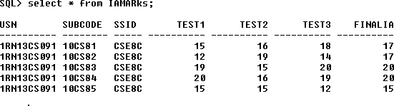

### Categorize students based on the following criterion: If FinalIA = 17 to 20 then CAT = ‘Outstanding’

**If FinalIA = 12 to 16 then CAT = ‘Average’ If FinalIA< 12 then CAT = ‘Weak’**

### Give these details only for 8th semester A, B, and C section students.

SELECT S.USN,S.SNAME,S.ADDRESS,S.PHONE,S.GENDER, (CASE

WHEN IA.FINALIA BETWEEN 17 AND 20 THEN 'OUTSTANDING' WHEN IA.FINALIA BETWEEN 12 AND 16 THEN 'AVERAGE' ELSE 'WEAK'

END) AS CAT

FROM STUDENT S, SEMSEC SS, IAMARKS IA, SUBJECT SUB WHERE S.USN = IA.USN AND

SS.SSID = IA.SSID AND SUB.SUBCODE = IA.SUBCODE AND SUB.SEM = 8;

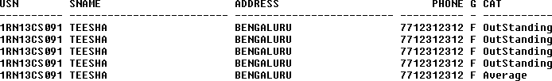

### Consider the schema for Company Database:

**EMPLOYEE (*SSN, Name, Address, Sex, Salary, SuperSSN, DNo*) DEPARTMENT (*DNo, DName, MgrSSN, MgrStartDate*) DLOCATION (*DNo,DLoc*)**

**PROJECT (*PNo, PName, PLocation, DNo*) WORKS_ON (*SSN, PNo, Hours*)**

**Write SQL queries to**

* 1. **Make a list of all project numbers for projects that involve an employee whose last name is ‘Scott’, either as a worker or as a manager of the department that controls the project.**
  2. **Show the resulting salaries if every employee working on the ‘IoT’ project is given a 10 percent raise.**
  3. **Find the sum of the salaries of all employees of the ‘Accounts’ department, as well as the maximum salary, the minimum salary, and the average salary in this department**
  4. **Retrieve the name of each employee who works on all the projects controlled by department number 5 (use NOT EXISTS operator). For each department that has more than five employees, retrieve the department number and the number of its employees who are making more than Rs. 6,00,000.**

**Schema Diagram**

***Employee***



***DLocation DNO DLOC***

***Project***



|  |  |  |  |  |  |  |  |
| --- | --- | --- | --- | --- | --- | --- | --- |
| ***SSN*** | *Fname* | *Lname* | *Address* | *Sex* | *Salary* | *SuperSSN* | *DNO* |

|  |  |  |  |
| --- | --- | --- | --- |
| ***Depart*** | ***ment*** |  |  |
|  |  |  |  |
| ***DNO*** | *Dname* | *MgrSSN* | *MgrStartDate* |

|  |  |  |  |
| --- | --- | --- | --- |
| ***PNO*** | *PName* | *PLocation* | *DNO* |
| ***Works*** | ***_on*** |  |  |

|  |  |  |
| --- | --- | --- |
| ***SSN*** | ***PNO*** | *Hours* |

**Table Creation**

CREATE TABLE DEPARTMENT

(DNO VARCHAR2 (20) PRIMARY KEY, DNAME VARCHAR2 (20), MGRSTARTDATE DATE);

CREATE TABLE EMPLOYEE

(SSN VARCHAR2 (20) PRIMARY KEY, FNAME VARCHAR2 (20),

LNAME VARCHAR2 (20),

ADDRESS VARCHAR2 (20),

SEX CHAR (1), SALARY INTEGER,

SUPERSSN REFERENCES EMPLOYEE (SSN), DNO REFERENCES DEPARTMENT (DNO));

**NOTE:** Once DEPARTMENT and EMPLOYEE tables are created we must alter department table to add foreign constraint MGRSSN using sql command

ALTER TABLE DEPARTMENT

ADD MGRSSN REFERENCES EMPLOYEE (SSN);

CREATE TABLE DLOCATION (DLOC VARCHAR2 (20),

DNO REFERENCES DEPARTMENT (DNO), PRIMARY KEY (DNO, DLOC));

CREATE TABLE PROJECT (PNO INTEGER PRIMARY KEY, PNAME VARCHAR2 (20),

PLOCATION VARCHAR2 (20),

DNO REFERENCES DEPARTMENT (DNO));

CREATE TABLE WORKS_ON (HOURS NUMBER (2),

SSN REFERENCES EMPLOYEE (SSN), PNO REFERENCES PROJECT(PNO), PRIMARY KEY (SSN, PNO));

**Table Descriptions**

DESC EMPLOYEE;

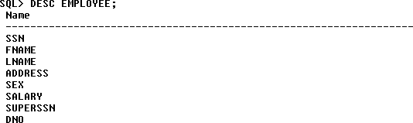

DESC DEPARTMENT;

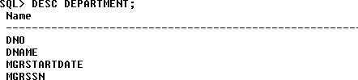

DESC DLOCATION;

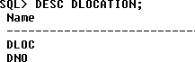

DESC PROJECT;

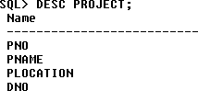

DESC WORKS_ON;

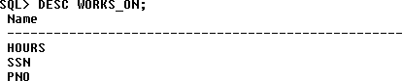

**Insertion of values to tables**

INSERT INTO EMPLOYEE (SSN, FNAME, LNAME, ADDRESS, SEX, SALARY) VALUES (‘RNSECE01’,’JOHN’,’SCOTT’,’BANGALORE’,’M’, 450000);

INSERT INTO EMPLOYEE (SSN, FNAME, LNAME, ADDRESS, SEX, SALARY) VALUES (‘RNSCSE01’,’JAMES’,’SMITH’,’BANGALORE’,’M’, 500000);

INSERT INTO EMPLOYEE (SSN, FNAME, LNAME, ADDRESS, SEX, SALARY) VALUES (‘RNSCSE02’,’HEARN’,’BAKER’,’BANGALORE’,’M’, 700000);

INSERT INTO EMPLOYEE (SSN, FNAME, LNAME, ADDRESS, SEX, SALARY) VALUES (‘RNSCSE03’,’EDWARD’,’SCOTT’,’MYSORE’,’M’, 500000);

INSERT INTO EMPLOYEE (SSN, FNAME, LNAME, ADDRESS, SEX, SALARY) VALUES (‘RNSCSE04’,’PAVAN’,’HEGDE’,’MANGALORE’,’M’, 650000);

INSERT INTO EMPLOYEE (SSN, FNAME, LNAME, ADDRESS, SEX, SALARY) VALUES (‘RNSCSE05’,’GIRISH’,’MALYA’,’MYSORE’,’M’, 450000);

INSERT INTO EMPLOYEE (SSN, FNAME, LNAME, ADDRESS, SEX, SALARY) VALUES (‘RNSCSE06’,’NEHA’,’SN’,’BANGALORE’,’F’, 800000);

INSERT INTO EMPLOYEE (SSN, FNAME, LNAME, ADDRESS, SEX, SALARY) VALUES (‘RNSACC01’,’AHANA’,’K’,’MANGALORE’,’F’, 350000);

INSERT INTO EMPLOYEE (SSN, FNAME, LNAME, ADDRESS, SEX, SALARY) VALUES (‘RNSACC02’,’SANTHOSH’,’KUMAR’,’MANGALORE’,’M’, 300000);

INSERT INTO EMPLOYEE (SSN, FNAME, LNAME, ADDRESS, SEX, SALARY) VALUES (‘RNSISE01’,’VEENA’,’M’,’MYSORE’,’M’, 600000);

INSERT INTO EMPLOYEE (SSN, FNAME, LNAME, ADDRESS, SEX, SALARY) VALUES (‘RNSIT01’,’NAGESH’,’HR’,’BANGALORE’,’M’, 500000);

INSERT INTO DEPARTMENT VALUES (‘1’,’ACCOUNTS’,’01-JAN-01’,’RNSACC02’); INSERT INTO DEPARTMENT VALUES (‘2’,’IT’,’01-AUG-16’,’AMCEC01’);

INSERT INTO DEPARTMENT VALUES (‘3’,’ECE’,’01-JUN-08’,’RNSECE01’); INSERT INTO DEPARTMENT VALUES (‘4’,’ISE’,’01-AUG-15’,’RNSISE01’); INSERT INTO DEPARTMENT VALUES (‘5’,’CSE’,’01-JUN-02’,’RNSCSE05’);

### Note: update entries of employee table to fill missing fields SUPERSSN and DNO

UPDATE EMPLOYEE SET SUPERSSN=NULL, DNO=’3’ WHERE SSN=’RNSECE01’;

UPDATE EMPLOYEE SET SUPERSSN=’RNSCSE02’, DNO=’5’ WHERE SSN=’RNSCSE01’;

UPDATE EMPLOYEE SET

SUPERSSN=’RNSCSE03’, DNO=’5’ WHERE SSN=’RNSCSE02’;

UPDATE EMPLOYEE SET SUPERSSN=’RNSCSE04’, DNO=’5’ WHERE SSN=’RNSCSE03’;

UPDATE EMPLOYEE SET DNO=’5’, SUPERSSN=’RNSCSE05’ WHERE SSN=’RNSCSE04’;

UPDATE EMPLOYEE SET DNO=’5’, SUPERSSN=’RNSCSE06’ WHERE SSN=’RNSCSE05’;

UPDATE EMPLOYEE SET DNO=’5’, SUPERSSN=NULL WHERE SSN=’RNSCSE06’;

UPDATE EMPLOYEE SET DNO=’1’, SUPERSSN=’RNSACC02’ WHERE SSN=’RNSACC01’;

UPDATE EMPLOYEE SET DNO=’1’, SUPERSSN=NULL WHERE SSN=’RNSACC02’;

UPDATE EMPLOYEE SET DNO=’4’, SUPERSSN=NULL WHERE SSN=’RNSISE01’;

UPDATE EMPLOYEE SET DNO=’2’, SUPERSSN=NULL WHERE SSN=’AMCEC01’;

INSERT INTO DLOCATION VALUES (’BANGALORE’, ‘1’); INSERT INTO DLOCATION VALUES (’BANGALORE’, ‘2’); INSERT INTO DLOCATION VALUES (’BANGALORE’, ‘3’); INSERT INTO DLOCATION VALUES (’MANGALORE’, ‘4’); INSERT INTO DLOCATION VALUES (’MANGALORE’, ‘5’);

INSERT INTO PROJECT VALUES (100,’IOT’,’BANGALORE’,’5’); INSERT INTO PROJECT VALUES (101,’CLOUD’,’BANGALORE’,’5’); INSERT INTO PROJECT VALUES (102,’BIGDATA’,’BANGALORE’,’5’); INSERT INTO PROJECT VALUES (103,’SENSORS’,’BANGALORE’,’3’);

INSERT INTO PROJECT VALUES (104,’BANK MANAGEMENT’,’BANGALORE’,’1’); INSERT INTO PROJECT VALUES (105,’SALARY MANAGEMENT’,’BANGALORE’,’1’); INSERT INTO PROJECT VALUES (106,’OPENSTACK’,’BANGALORE’,’4’);

INSERT INTO PROJECT VALUES (107,’SMART CITY’,’BANGALORE’,’2’);

INSERT INTO WORKS_ON VALUES (4, ‘RNSCSE01’, 100); INSERT INTO WORKS_ON VALUES (6, ‘RNSCSE01’, 101); INSERT INTO WORKS_ON VALUES (8, ‘RNSCSE01’, 102); INSERT INTO WORKS_ON VALUES (10, ‘RNSCSE02’, 100); INSERT INTO WORKS_ON VALUES (3, ‘RNSCSE04’, 100); INSERT INTO WORKS_ON VALUES (4, ‘RNSCSE05’, 101); INSERT INTO WORKS_ON VALUES (5, ‘RNSCSE06’, 102); INSERT INTO WORKS_ON VALUES (6, ‘RNSCSE03’, 102); INSERT INTO WORKS_ON VALUES (7, ‘RNSECE01’, 103); INSERT INTO WORKS_ON VALUES (5, ‘RNSACC01’, 104); INSERT INTO WORKS_ON VALUES (6, ‘RNSACC02’, 105); INSERT INTO WORKS_ON VALUES (4, ‘RNSISE01’, 106); INSERT INTO WORKS_ON VALUES (10, ‘AMCEC01’, 107);

SELECT * FROM EMPLOYEE;

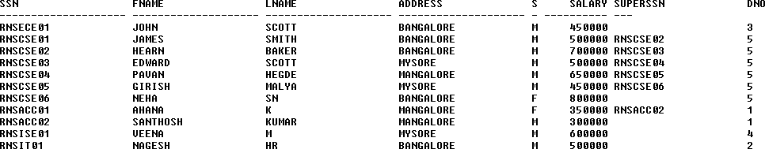

SELECT * FROM DEPARTMENT;

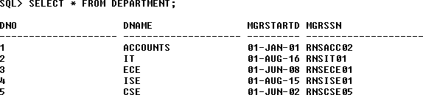

SELECT * FROM DLOCATION;

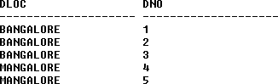

SELECT * FROM PROJECT;

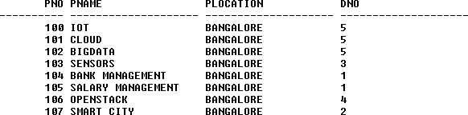

SELECT * FROM WORKS_ON;

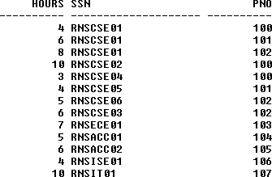

**Queries:**

1. **Make a list of all project numbers for projects that involve an employee whose last name is ‘Scott’, either as a worker or as a manager of the department that controls the project.**

(SELECT DISTINCT P.PNO

FROM PROJECT P, DEPARTMENT D, EMPLOYEE E WHERE E.DNO=D.DNO

AND D.MGRSSN=E.SSN AND E.LNAME=’SCOTT’) UNION

(SELECT DISTINCT P1.PNO

FROM PROJECT P1, WORKS_ON W, EMPLOYEE E1 WHERE P1.PNO=W.PNO

AND E1.SSN=W.SSN

AND E1.LNAME=’SCOTT’);



### Show the resulting salaries if every employee working on the ‘IoT’ project is given a 10 percent raise.

SELECT E.FNAME, E.LNAME, 1.1*E.SALARY AS INCR_SAL FROM EMPLOYEE E, WORKS_ON W, PROJECT P

WHERE E.SSN=W.SSN AND W.PNO=P.PNO AND P.PNAME=’IOT’;

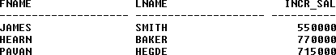

### Find the sum of the salaries of all employees of the ‘Accounts’ department, as well as the maximum salary, the minimum salary, and the average salary in this department

SELECT SUM (E.SALARY), MAX (E.SALARY), MIN (E.SALARY), AVG (E.SALARY)

FROM EMPLOYEE E, DEPARTMENT D

WHERE E.DNO=D.DNO

AND D.DNAME=’ACCOUNTS’;



### Retrieve the name of each employee who works on all the projects Controlled by department number 5 (use NOT EXISTS operator).

SELECT E.FNAME, E.LNAME FROM EMPLOYEE E

WHERE NOT EXISTS((SELECT PNO

FROM PROJECT WHERE DNO=’5’) MINUS (SELECT PNO FROM WORKS_ON WHERE E.SSN=SSN));



### For each department that has more than five employees, retrieve the department number and the number of its employees who are making more than Rs. 6, 00,000.

SELECT D.DNO, COUNT (*)

FROM DEPARTMENT D, EMPLOYEE E WHERE D.DNO=E.DNO

AND E.SALARY>600000

AND D.DNO IN (SELECT E1.DNO FROM EMPLOYEE E1 GROUP BY E1.DNO HAVING COUNT (*)>5)

GROUP BY D.DNO;



**Sample list of Mini Projects**

* Bus Reservation System
* Hostel Management System
* Art Gallery Management System
* Human Resource Management
* Online Blood Bank
* Online Car Rental
* Online Pizza Ordering System
* Hospital Management System
* Multiplex Theatre Booking System
* Airline Reservation System
* Railway Reservation
* Student Voting System
* Hotel Management System
* Police & Criminal Record Management System
* Library Management System
* A&C Medicare
* Employee Payroll Management System
* Training & Placement Management System
* Online Voting System
* Banking Management System
* College Event Management
* Restaurant Billing System
* Hotel Database Management System
* Railway Management System
* Pharmacy Management System
* ATM Transaction Management System
* Pet Shop Management System
* Online Quiz System
* Inventory Control System
* IT Training Group Database Management System
* Wholesale Management System
* Salary Management System
* Etc..etc…

## Most likely Viva Questions

### What is SQL?

Structured Query Language

### What is database?

A database is a logically coherent collection of data with some inherent meaning, representing some aspect of real world and which is designed, built and populated with data for a specific purpose.

### What is DBMS?

It is a collection of programs that enables user to create and maintain a database. In other words it is general-purpose software that provides the users with the processes of defining, constructing and manipulating the database for various applications.

### What is a Database system?

The database and DBMS software together is called as Database system.

### Advantages of DBMS?

* + Redundancy is controlled.
  + Unauthorized access is restricted.
  + Providing multiple user interfaces.
  + Enforcing integrity constraints.
  + Providing backup and recovery.

### Disadvantage in File Processing System?

* + Data redundancy & inconsistency.
  + Difficult in accessing data.
  + Data isolation.
  + Data integrity.
  + Concurrent access is not possible.
  + Security Problems.

### Describe the three levels of data abstraction?

There are three levels of abstraction:

* + Physical level: The lowest level of abstraction describes how data are stored.
  + Logical level*:* The next higher level of abstraction, describes what data are stored in database and what relationship among those data.
  + View level:The highest level of abstraction describes only part of entire database.

### Define the "integrity rules"

There are two Integrity rules.

* + Entity Integrity:States that “Primary key cannot have NULL value”
  + Referential Integrity:States that “Foreign Key can be either a NULL value or should be Primary Key value of other relation.

### What is extension and intension?

Extension - It is the number of tuples present in a table at any instance. This is time dependent.

Intension -It is a constant value that gives the name, structure of table and the constraints laid on it.

### What is Data Independence?

Data independence means that “the application is independent of the storage structure and access strategy of data”. In other words, The ability to modify the schema definition in one level should not affect the schema definition in the next higher level.

Two types of Data Independence:

* + Physical Data Independence: Modification in physical level should not affect the logical level.
  + Logical Data Independence: Modification in logical level should affect the view level.

NOTE: Logical Data Independence is more difficult to achieve

### What is a view? How it is related to data independence?

A view may be thought of as a virtual table, that is, a table that does not really exist in its own right but is instead derived from one or more underlying base table. In other words, there is no stored file that direct represents the view instead a definition of view is stored in data dictionary.

Growth and restructuring of base tables is not reflected in views. Thus the view can insulate users from the effects of restructuring and growth in the database. Hence accounts for logical data independence.

### What is Data Model?

A collection of conceptual tools for describing data, data relationships data semantics and constraints.

### What is E-R model?

This data model is based on real world that consists of basic objects called entities and of relationship among these objects. Entities are described in a database by a set of attributes.

### What is Object Oriented model?

This model is based on collection of objects. An object contains values stored in instance variables within the object. An object also contains bodies of code that operate on the object. These bodies of code are called methods. Objects that contain same types of values and the same methods are grouped together into classes.

### What is an Entity?

It is an 'object' in the real world with an independent existence.

### What is an Entity type?

It is a collection (set) of entities that have same attributes.

### What is an Entity set?

It is a collection of all entities of particular entity type in the database.

### What is an Extension of entity type?

The collections of entities of a particular entity type are grouped together into an entity

set.

### What is an attribute?

It is a particular property, which describes the entity.

### What is a Relation Schema and a Relation?

A relation Schema denoted by R(A1, A2, …, An) is made up of the relation name R and the list of attributes Ai that it contains. A relation is defined as a set of tuples. Let r be the relation which contains set tuples (t1, t2, t3, ...,tn). Each tuple is an ordered list of n- values t=(v1,v2, ..., vn).

### What is degree of a Relation?

It is the number of attribute of its relation schema.

### What is Relationship?

It is an association among two or more entities.

### What is Relationship set?

The collection (or set) of similar relationships.

1. ***What is Relationship type?***

Relationship type defines a set of associations or a relationship set among a given set of entity types.

### What is degree of Relationship type?

It is the number of entity type participating.

### What is DDL (Data Definition Language)?

A data base schema is specified by a set of definitions expressed by a special language called DDL.

### What is VDL (View Definition Language)?

It specifies user views and their mappings to the conceptual schema.

### What is SDL (Storage Definition Language)?

This language is to specify the internal schema. This language may specify the mapping between two schemas.

### What is Data Storage - Definition Language?

The storage structures and access methods used by database system are specified by a set of definition in a special type of DDL called data storage- definition language.

### What is DML (Data Manipulation Language)?

This language that enable user to access or manipulate data as organized by appropriate data model.

* + Procedural DML or Low level: DML requires a user to specify what data are needed and how to get those data.
  + Non-Procedural DML or High level: DML requires a user to specify what data are needed without specifying how to get those data.

### What is DML Compiler?

It translates DML statements in a query language into low-level instruction that the query evaluation engine can understand.

1. **What is Relational Algebra?**

It is a procedural query language. It consists of a set of operations that take one or two relations as input and produce a new relation.

### What is Relational Calculus?

It is an applied predicate calculus specifically tailored for relational databases proposed by E.F. Codd. E.g. of languages based on it are DSL, ALPHA, QUEL.

### What is normalization?

It is a process of analyzing the given relation schemas based on their Functional Dependencies (FDs) and primary key to achieve the properties

* + Minimizing redundancy
  + Minimizing insertion, deletion and update anomalies.

### What is Functional Dependency?

A Functional dependency is denoted by X Y between two sets of attributes X and Y that are subsets of R specifies a constraint on the possible tuple that can form a relation state r of

### R. What is Lossless join property?

It guarantees that the spurious tuple generation does not occur with respect to relation schemas after decomposition.

### What is 1 NF (Normal Form)?

The domain of attribute must include only atomic (simple, indivisible) values.

### What is Fully Functional dependency?

It is based on concept of full functional dependency. A functional dependency X Y is fully functional dependency if removal of any attribute A from X means that the dependency does not hold any more.

### What is 2NF?

A relation schema R is in 2NF if it is in 1NF and every non-prime attribute A in R is fully functionally dependent on primary key.

### What is 3NF?

A relation schema R is in 3NF if it is in 2NF and for every FD X A either of the following is true

* X is a Super-key of R.
* A is a prime attribute of R.

In other words, if every non prime attribute is non-transitively dependent on primary key.

### What is BCNF (Boyce-Codd Normal Form)?

A relation schema R is in BCNF if it is in 3NF and satisfies additional constraints that for every FD X A, X must be a candidate key.

### What is 4NF?

A relation schema R is said to be in 4NF if for every Multivalued dependency X Y that holds over R, one of following is true

* X is subset or equal to (or) XY = R.
* X is a super key.

### What is 5NF?

A Relation schema R is said to be 5NF if for every join dependency {R1, R2, ...,Rn} that holds R, one the following is true

* Ri = R for some i.
* The join dependency is implied by the set of FD, over R in which the left side is key of R.

### What is Domain-Key Normal Form?

A relation is said to be in DKNF if all constraints and dependencies that should hold on the constraint can be enforced by simply enforcing the domain constraint and key constraint on the relation.

### What is a Partial key and Compound key?

Partial Key:

It is a set of attributes that can uniquely identify weak entities and that are related to same owner entity. It is sometime called as Discriminator.

Compound Key**:**

If no single data element uniquely identifies occurrences within a construct, then combining multiple elements to create a unique identifier for the construct is known as creating a compound key.

### What is system catalog or catalog relation? How is better known as?

A RDBMS maintains a description of all the data that it contains, information about every relation and index that it contains. This information is stored in a collection of relations maintained by the system called metadata. It is also called data dictionary.

### What is join dependency and inclusion dependency?

Join Dependency:

A Join dependency is generalization of Multivalued dependency.A JD

{R1, R2, ...,Rn} is said to hold over a relation R if R1, R2, R3, ..., Rn is a lossless-join decomposition of R . There is no set of sound and complete inference rules for JD.

Inclusion Dependency:

An Inclusion Dependency is a statement of the form that some columns of a relation are contained in other columns. A foreign key constraint is an example of inclusion dependency.

### What is durability in DBMS?

Once the DBMS informs the user that a transaction has successfully completed, its effects should persist even if the system crashes before all its changes are reflected on disk. This property is called durability.

### What do you mean by atomicity and aggregation?

Atomicity:

Either all actions are carried out or none are. Users should not have to worry about the effect of incomplete transactions. DBMS ensures this by undoing the actions of incomplete transactions.

Aggregation*:*

A concept which is used to model a relationship between a collection of entities and relationships. It is used when we need to express a relationship among relationships.

### What is a Phantom Deadlock?

In distributed deadlock detection, the delay in propagating local information might cause the deadlock detection algorithms to identify deadlocks that do not really exist. Such situations are called phantom deadlocks and they lead to unnecessary aborts.

### What is a checkpoint and when does it occur?

A Checkpoint is like a snapshot of the DBMS state. By taking checkpoints, the DBMS can reduce the amount of work to be done during restart in the event of subsequent crashes.

### What are the different phases of transaction?

Different phases are

* + Analysis phase
  + Redo Phase
  + Undo phase

### What do you mean by flat file database?

It is a database in which there are no programs or user access languages. It has no cross- file capabilities but is user-friendly and provides user-interface management.

### What is "transparent DBMS"?

It is one, which keeps its Physical Structure hidden from user.

### What is a query?

A query with respect to DBMS relates to user commands that are used to interact with a data base. The query language can be classified into data definition language and data manipulation language.

### What do you mean by Correlated subquery?

Subqueries, or nested queries, are used to bring back a set of rows to be used by the parent query. Depending on how the subquery is written, it can be executed once for the parent query or it can be executed once for each row returned by the parent query. If the subquery is executed for each row of the parent, this is called a *correlated subquery*.

### What are the primitive operations common to all record management systems?

Addition, deletion and modification.

### What are the unary operations in Relational Algebra?

PROJECTION and SELECTION.

### Are the resulting relations of PRODUCT and JOIN operation the same?

No.

*PRODUCT*: Concatenation of every row in one relation with every row in another.

*JOIN*: Concatenation of rows from one relation and related rows from another.

### Name the sub-systems of a RDBMS

I/O, Security, Language Processing, Process Control, Storage Management, Logging and Recovery, Distribution Control, Transaction Control, Memory Management, Lock Management

### Which part of the RDBMS takes care of the data dictionary? How?

Data dictionary is a set of tables and database objects that is stored in a special area of the database and maintained exclusively by the kernel.

1. **What is the job of the information stored in data-dictionary?**The information in the data dictionary validates the existence of the objects, provides access to them, and maps the actual physical storage location.

### How do you communicate with an RDBMS?

You communicate with an RDBMS using Structured Query Language (SQL)

### Define SQL and state the differences between SQL and other conventional programming Languages

SQL is a nonprocedural language that is designed specifically for data access operations on normalized relational database structures. The primary difference between SQL and other conventional programming languages is that SQL statements specify what data operations should be performed rather than how to perform them.

### Name the three major set of files on disk that compose a database in Oracle

There are three major sets of files on disk that compose a database. All the files are binary. These are

* + Database files
  + Control files
  + Redo logs

The most important of these are the database files where the actual data resides. The control files and the redo logs support the functioning of the architecture itself.

All three sets of files must be present, open, and available to Oracle for any data on the database to be useable. Without these files, you cannot access the database, and the database administrator might have to recover some or all of the database using a backup, if there is one.

### What is ROWID?

The ROWID is a unique database-wide physical address for every row on every table. Once assigned (when the row is first inserted into the database), it never changes until the row is deleted or the table is dropped.

The ROWID consists of the following three components, the combination of which uniquely identifies the physical storage location of the row.

* + Oracle database file number, which contains the block with the rows
  + Oracle block address, which contains the row
  + The row within the block (because each block can hold many rows)

The ROWID is used internally in indexes as a quick means of retrieving rows with a particular key value. Application developers also use it in SQL statements as a quick way to access a row once they know the ROWID

### What is database Trigger?

A database trigger is a PL/SQL block that can defined to automatically execute for insert, update, and delete statements against a table. The trigger can e defined to execute once for the entire statement or once for every row that is inserted, updated, or deleted. For any one table, there are twelve events for which you can define database triggers. A database trigger can call database procedures that are also written in PL/SQL.

### What are stored-procedures? And what are the advantages of using them.

Stored procedures are database objects that perform a user defined operation. A stored procedure can have a set of compound SQL statements. A stored procedure executes the SQL commands and returns the result to the client. Stored procedures are used to reduce network traffic.

### Spurious tuples may occur due to

1. Bad normalization
2. Theta joins
3. Updating tables from join
   1. i& ii b) ii & iii

c) i& iii d) ii & iii

1. i& iii because theta joins are joins made on keys that are not primary keys.

### A dominant entity is the entity

1. on the N side in a 1 : N relationship
2. on the 1 side in a 1 : N relationship
3. on either side in a 1 : 1 relationship
4. nothing to do with 1 : 1 or 1 : N relationship
5. on the 1 side in a 1 : N relationship

### What is Storage Manager?

It is a program module that provides the interface between the low-level data stored in database, application programs and queries submitted to the system.

### What is Buffer Manager?

It is a program module, which is responsible for fetching data from disk storage into main memory and deciding what data to be cache in memory.

### What is Transaction Manager?

It is a program module, which ensures that database, remains in a consistent state despite system failures and concurrent transaction execution proceeds without conflicting.

### What is File Manager?

It is a program module, which manages the allocation of space on disk storage and data structure used to represent information stored on a disk.

### What is Authorization and Integrity manager?

It is the program module, which tests for the satisfaction of integrity constraint and checks the authority of user to access data.

### What are stand-alone procedures?

Procedures that are not part of a package are known as stand-alone because they independently defined. A good example of a stand-alone procedure is one written in a SQL*Forms application. These types of procedures are not available for reference from other Oracle tools. Another limitation of stand-alone procedures is that they are compiled at run time, which slows execution.

### What are cursors give different types of cursors.

PL/SQL uses cursors for all database information accesses statements. The language supports the use two types of cursors

* *Implicit*
* *Explicit*

### What do you understand by dependency preservation?

Given a relation R and a set of FDs F, dependency preservation states that the closure of the union of the projection of F on each decomposed relation Ri is equal to the closure of F. i.e.,

((R1(F)) U … U (Rn(F)))+= F+

if decomposition is not dependency preserving, then some dependency is lost in the decomposition.

## Content Beyond Syllabus

**Part A.** For connecting java application with the mysql database, you need to follow 5 steps to perform database connectivity.

In this example we are using MySql as the database. So we need to know following informations for the mysql database:

1. **Driver class**: The driver class for the mysql database is com.mysql.jdbc.Driver.
2. **Connection URL**: The connection URL for the mysql database **is jdbc:mysql://localhost:3306/sonoo** where jdbc is the API, mysql is the database, localhost is the server name on which mysql is running, we may also use IP address, 3306 is the port number and sonoo is the database name. We may use any database, in such case, you need to replace the sonoo with your database name.
3. **Username**: The default username for the mysql database is root.
4. **Password**: Password is given by the user at the time of installing the mysql database. In this example, we are going to use root as the password.

Let's first create a table in the mysql database, but before creating table, we need to create database first.

1. create database sonoo;
2. use sonoo;
3. create table emp(id int(10),name varchar(40),age int(3)); Example to Connect Java Application with mysql database

In this example, sonoo is the database name, root is the username and password.

import java.sql.*; class MysqlCon{

public static void main(String args[]){ try{ Class.forName("com.mysql.jdbc.Driver");

Connection con=DriverManager.getConnection( "jdbc:mysql://localhost:3306/sonoo","r oot","root"); //here sonoo is database name, root is username and password

Statement stmt=con.createStatement();

ResultSet rs=stmt.executeQuery("select * from emp"); while(rs.next())

System.out.println(rs.getInt(1)+" "+rs.getString(2)+" "+rs.getString(3)); con.close();

}catch(Exception e){ System.out.println(e);}

} }

To connect java application with the mysql database mysqlconnector.jar file is required to be loaded.

Two ways to load the jar file:

* 1. paste the mysqlconnector.jar file in jre/lib/ext folder
  2. set classpath

1. paste the mysqlconnector.jar file in JRE/lib/ext folder:

Download the mysqlconnector.jar file. Go to jre/lib/ext folder and paste the jar file here.

1. set classpath:

There are two ways to set the classpath:

* + temporary
  + permanent

How to set the temporary classpath open command prompt and write:

1. C:>set classpath=c:\folder\mysql-connector-java-5.0.8-bin.jar;.; How to set the permanent classpath

Go to environment variable then click on new tab. In variable name write classpath and in

variable value paste the path to the mysqlconnector.jar file by appending mysqlconnector.jar;.; as C:\folder\mysql-connector-java-5.0.8-bin.jar;.;

### Part B. PL/SQL If

Example of PL/SQL If Statement

1. DECLARE

2. a number(3) := 500;

1. BEGIN
2. -- check the boolean condition using if statement
3. IF( a < 20 ) THEN
4. -- if condition is true then print the following
5. dbms_output.put_line('a is less than 20 ' );
6. ELSE
7. dbms_output.put_line('a is not less than 20 ' );
8. END IF;
9. dbms_output.put_line('value of a is : ' || a);
10. END;

### PL/SQL Loop

The PL/SQL loops are used to repeat the execution of one or more statements for specified number of times. These are also known as iterative control statements.

There are 4 types of PL/SQL Loops.

* 1. Basic Loop / Exit Loop
  2. While Loop
  3. For Loop
  4. Cursor For Loop

### Example of PL/SQL EXIT Loop

1. DECLARE
2. i NUMBER := 1;
3. BEGIN
4. LOOP
5. EXIT WHEN i>10;
6. DBMS_OUTPUT.PUT_LINE(i); 7. i := i+1;
7. END LOOP;
8. END;